

Final Project Report

Submitted By – Shreyash Uday Mhettar
College Name – Dr. D. Y. Patil Pratishthan's College of Engineering Salokhenagar Kolhapur
Branch – Data Science
Roll id – B.Tech – 33
Project Name - Global AI Adoption in Education: A Comprehensive Global
Performance Intelligence Report

- Introduction
1.1. Project overviews
Artificial Intelligence (AI) is rapidly transforming the education sector by enhancing teaching methods, improving student learning experiences, and supporting educational institutions in making data-driven decisions. AI technologies such as intelligent tutoring systems, personalized learning platforms, virtual assistants, and automated assessment tools are increasingly being adopted worldwide.
This project analyzes global AI adoption in education using a dataset containing 1,360 records and 16 attributes from multiple countries and regions between 2015 and 2026. The dataset includes information on student AI usage, teacher AI usage, school AI adoption, AI tools used, internet penetration, education index, government AI policies, urban and rural AI usage, AI integration into curricula, and gender gaps in AI usage.
Using Tableau, the project transforms raw educational data into meaningful dashboards and visualizations that help identify trends, compare countries and regions, evaluate government initiatives, and measure the overall impact of AI on education.
The report provides insights that can assist policymakers, educational institutions, researchers, and organizations in understanding the current state of AI adoption and planning future educational strategies.

1.2. Objectives

The main objectives of this project are:
- To analyze the global adoption of Artificial Intelligence in the education sector.
- To compare AI adoption across different countries and regions.
- To study AI usage among students, teachers, and educational institutions.
- To identify the most widely used AI tools in education.
- To examine the relationship between internet penetration and AI adoption.
- To evaluate the impact of government AI policies on educational AI implementation.
- To compare AI usage between urban and rural areas.
- To analyze gender differences in AI adoption.
- To develop interactive Tableau dashboards for effective data visualization.
- To generate business insights and support data-driven decision-making in education

- Project Initialization and Planning Phase
  - Define Problem Statement
Artificial Intelligence (AI) is becoming an important part of the education sector worldwide. However, the level of AI adoption differs significantly across countries due to variations in infrastructure, internet accessibility, government policies, economic development, and digital literacy. Many educational institutions face challenges in understanding how effectively AI is being implemented and which factors influence its adoption.
Without proper data analysis, policymakers and educational organizations cannot accurately evaluate AI usage among students and teachers, identify regional differences, or measure the effectiveness of government initiatives. Therefore, there is a need for a comprehensive data analysis and visualization system that provides meaningful insights into global AI adoption in education.
This project aims to analyze global educational AI data and present interactive visualizations that help stakeholders understand adoption trends, compare countries, evaluate performance, and support informed decision-making.

  - Project Proposal (Proposed Solution)

To address the identified problem, this project proposes the development of an interactive Global AI Adoption in Education Intelligence Dashboard using Tableau.
The proposed solution includes the following steps:
    - Collect and analyze a global dataset containing AI adoption information in education.
    - Perform data cleaning and preprocessing to improve data quality and consistency.
    - Analyze AI adoption among students, teachers, and educational institutions.
    - Compare AI adoption across countries and geographical regions.
    - Evaluate the relationship between internet penetration, education index, and AI implementation.
    - Examine the impact of government AI policies on educational AI adoption.
    - Develop interactive dashboards with filters and visualizations to simplify data exploration.
    - Present insights through Tableau Story for effective reporting and decision-making.
The final dashboard enables users to explore AI adoption trends, identify high- and lowperforming regions, and gain actionable insights for future educational planning.

  - Initial Project Planning
The project was planned and executed through the following phases:

Phase Activities Performed
Problem Defined the objective of analyzing global AI adoption in education and Identification identified key business questions.
Collected a global AI in Education dataset containing 1,360 records and

Data Collection
16 attributes from multiple countries and regions.
Cleaned missing values, standardized formats, corrected inconsistencies,
Data Preprocessing and prepared the data for analysis.
Explored the dataset using descriptive statistics and identified important
Data Exploration trends and patterns.
Planned dashboard layout, selected appropriate charts, KPIs, maps,
Dashboard Design filters, and interactive elements.

Visualization
Created charts, graphs, maps, and calculated fields using Tableau. Development
Verified filter functionality, checked visualization accuracy, and ensured
Dashboard Testing dashboard responsiveness.
Final Report Documented the methodology, analysis, findings, conclusions, and Preparation future scope of the project.

- Data Collection and Preprocessing Phase

3.1. Data Collection Plan and Raw Data Sources Identified

The success of any data analytics project depends on the quality and relevance of the collected data. For this project, a structured data collection plan was followed to ensure that the dataset contained sufficient information for analyzing global AI adoption in education.

Data Collection Plan
- Selected a dataset related to Artificial Intelligence adoption in the education sector.
- Gathered data covering multiple countries and regions worldwide.
- Included data from 2015 to 2026 to analyze trends over time.
- Ensured that the dataset contained educational, technological, and policy-related variables.
- Imported the dataset into Tableau for analysis and visualization.

Raw Data Source

Attribute | Description
Dataset Name | Global AI in Education
File Format | CSV
Number of Records | 1,360
Number of Attributes | 16
Time Period | 2015–2026
Analysis Tool | Tableau
Data Type | Structured Tabular Data

Dataset Attributes
The dataset includes the following fields:
- Year
- Month
- Country
- Region
- Student AI Usage (%)
- Teacher AI Usage (%)
- Schools AI Adoption (%)
- Average Daily AI Usage (Minutes)
- Top AI Tool
- Internet Penetration (%)
- Education Index
- Government AI Policy
- Urban AI Usage (%)
- Rural AI Usage (%)
- AI in Curriculum
- Gender Gap in AI Usage (%)

3.2. Data Quality Report
Before performing analysis, the dataset was examined to identify quality issues that could affect the accuracy of the results.

Dataset Summary
Quality Metric | Result
Total Records | 1,360
Quality Metric | Result
Total Attributes | 16
Missing Values | 441
Duplicate Records | 0 (after verification)
File Format | CSV

Data Quality Observations
- The dataset contains 1,360 records and 16 attributes.
- A total of 441 missing values were identified.
- All missing values were found in the Government AI Policy column.
- No major inconsistencies were observed in numerical fields.
- Country and region names were kept consistent throughout the dataset.
- Numeric fields were verified to ensure they contained valid numerical values. • The dataset was suitable for visualization after preprocessing.

Data Quality Issues Identified
- Missing values in the Government AI Policy field.
- Possible differences in data availability across countries.
- Categorical values required standardization for consistent analysis.

3.3. Data Exploration and Preprocessing
Data preprocessing was performed to improve data quality before creating Tableau visualizations.

Data Exploration
The dataset was explored to understand its structure and identify important patterns.

The following analyses were performed:
- Examined the number of records and attributes.
- Reviewed numerical and categorical variables.
- Identified missing values.
- Studied AI adoption across countries and regions.
- Explored trends over different years.
- Compared AI usage among students, teachers, schools, urban areas, and rural areas.

Data Preprocessing Steps
- Imported the CSV dataset into Tableau.
- Checked for missing values.
- Verified data types for all columns.
- Standardized country and region names where necessary.
- Cleaned inconsistent categorical values.
- Handled missing values in the Government AI Policy field using appropriate methods (such as leaving them as null or categorizing them as "Unknown," depending on the analysis).
- Validated percentage fields to ensure values were within acceptable ranges.
- Prepared calculated fields required for dashboard visualizations.
- Verified the final dataset before building dashboards.
10.

Outcome of Preprocessing
After preprocessing:
- The dataset was clean and ready for analysis.
- Data consistency was improved.
- Missing values were properly handled.
- The dataset was successfully imported into Tableau for creating interactive dashboards and visualizations.

- Data Visualization
Data visualization is an essential step in data analytics that transforms raw data into meaningful charts, graphs, and dashboards. It enables users to quickly understand trends, compare performance across countries, identify patterns, and make informed decisions.
For this project, Tableau was used to create interactive visualizations that provide insights into global AI adoption in education. Different chart types, filters, and calculated fields were used to represent the data effectively.

4.1. Framing Business Questions
Before creating the visualizations, several business questions were defined to guide the analysis. These questions helped identify the most important insights that stakeholders would require.

Business Questions
- What is the overall level of AI adoption in education worldwide?
- Which countries show the highest and lowest AI adoption?
- How has AI adoption changed from 2015 to 2026?
- What is the average daily AI usage in different countries?
- How does AI usage differ between students and teachers?
- Which AI tools are most commonly used in education?
- How does AI adoption vary across different regions of the world?
- What is the difference between urban and rural AI usage?
- Which regions have higher school AI adoption?
- What percentage of educational institutions fall into High, Moderate, and Low AI adoption categories?
- How do government initiatives and infrastructure influence AI adoption?
- What insights can support policymakers in improving AI implementation in education?
These business questions formed the basis for developing the Tableau worksheets, dashboards, and story.

4.2. Developing Visualizations

Visualization 1: KPI Cards Purpose:
Provide a quick overview of the most important project metrics. Metrics Displayed
- Average Daily AI Usage: 32.82 minutes
- Total Records: 1,360
- Average Rural AI Usage: 21.60%
- Average Urban AI Usage: 33.56%

Insight
- Urban AI usage is significantly higher than rural AI usage.
- The dataset contains sufficient records for comprehensive analysis.
- KPI cards allow users to understand the project's key statistics immediately.

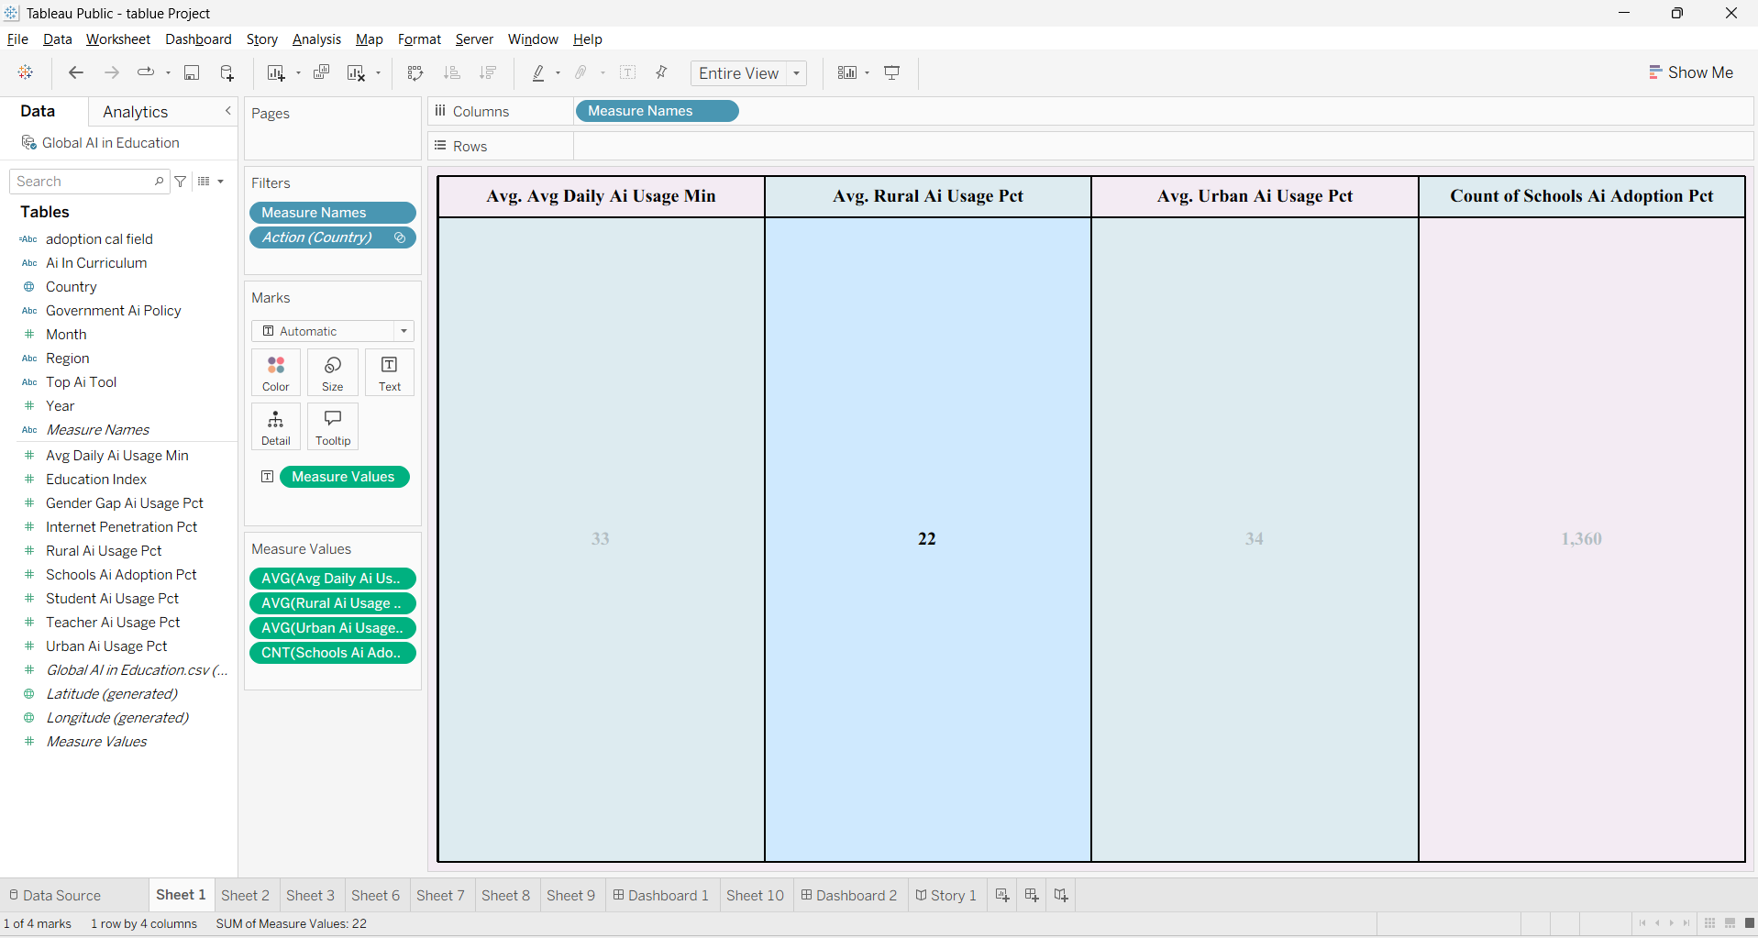

Visualization 2: Geographic Trends in Educational Development (Map) Chart Type: Filled Map Purpose
Displays the geographical distribution of AI adoption across different countries.

Countries Included
- Australia
- Brazil
- Canada
- China
- Germany
- India
- Nigeria
- Pakistan
- United Kingdom
- United States

Insight

- AI adoption data is available across multiple continents.
- Geographic visualization helps identify country-wise participation and regional distribution.
- Interactive filtering enables users to analyze individual countries.

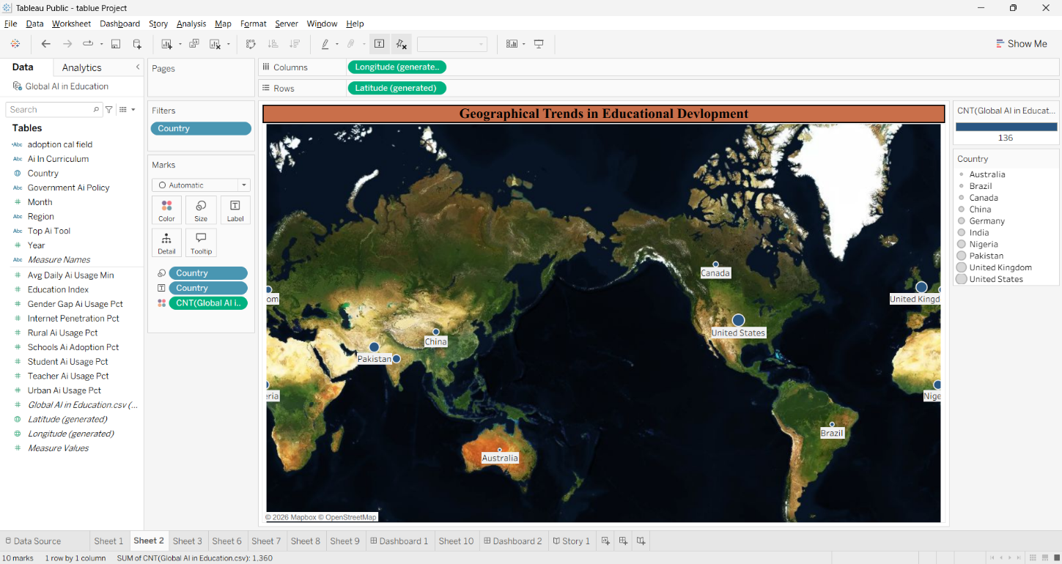

Visualization 3: Country-Level AI Adoption in Daily Practice Chart Type: Bar Chart Purpose
Compares the average daily AI usage among countries. Insight
- Canada shows the highest average daily AI usage.
- Brazil and the United States have comparatively lower average daily usage.
- Most countries have similar AI usage levels, indicating balanced adoption across the selected countries.

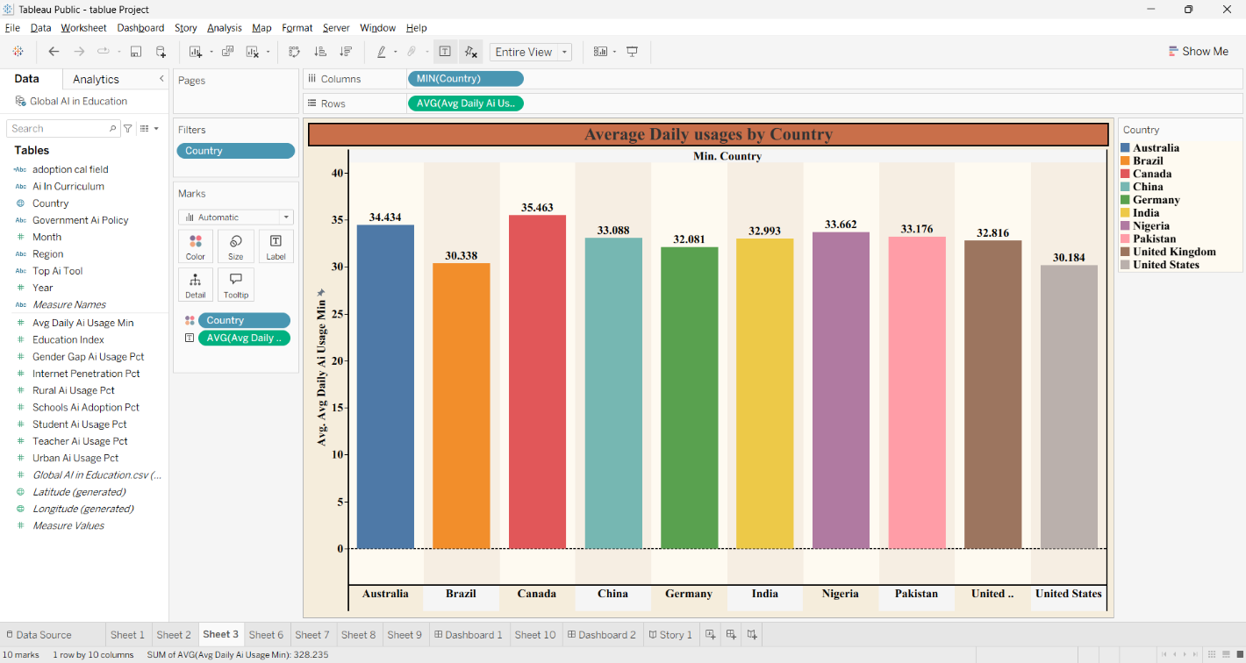

Visualization 4: Global Comparison of Student and Teacher AI Usage
Chart Type: Side-by-Side Bar Chart
Purpose
Compares AI usage between students and teachers in each country.

Insight
- Student AI usage is consistently higher than teacher AI usage.
- The difference is relatively small, indicating that both groups are actively adopting AI technologies.
- This visualization highlights stakeholder engagement in AI-based education.

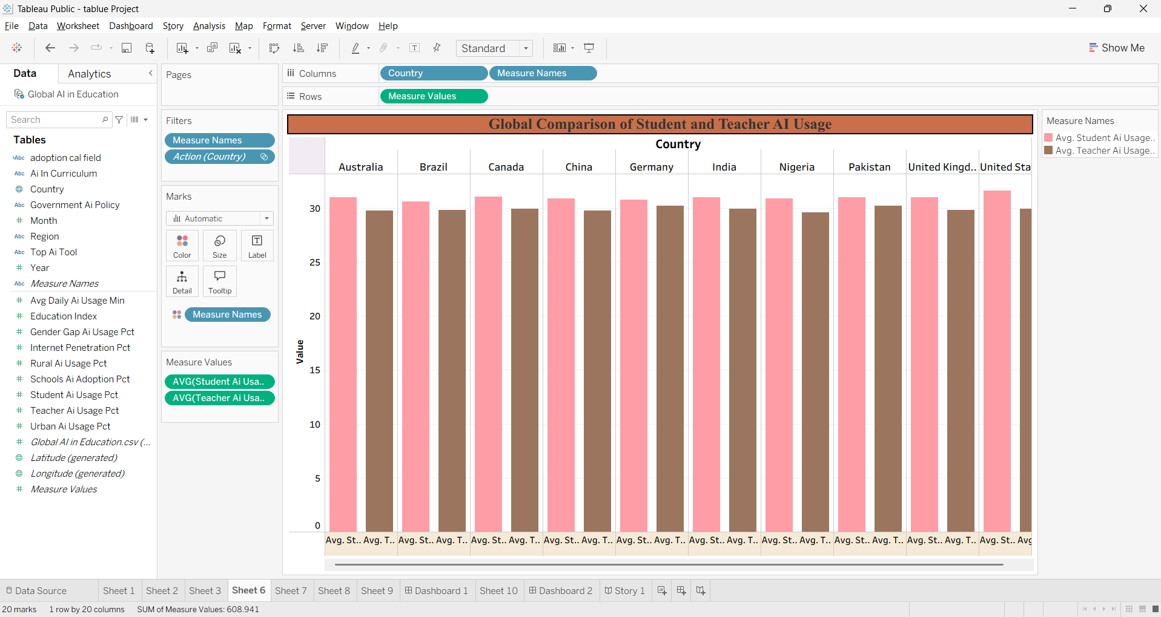

Visualization 5: AI Adoption Journey in Education (2015–2026) Chart Type: Line Chart Purpose
Shows yearly growth in:
- School AI Adoption
- Student AI Usage
- Teacher AI Usage

Insight
- AI adoption has increased steadily every year.
- Student AI usage reaches approximately 60.8% by 2026.
- Teacher AI usage reaches approximately 59%.
- School AI adoption also demonstrates continuous growth.
This visualization clearly shows the positive trend of AI integration into education.

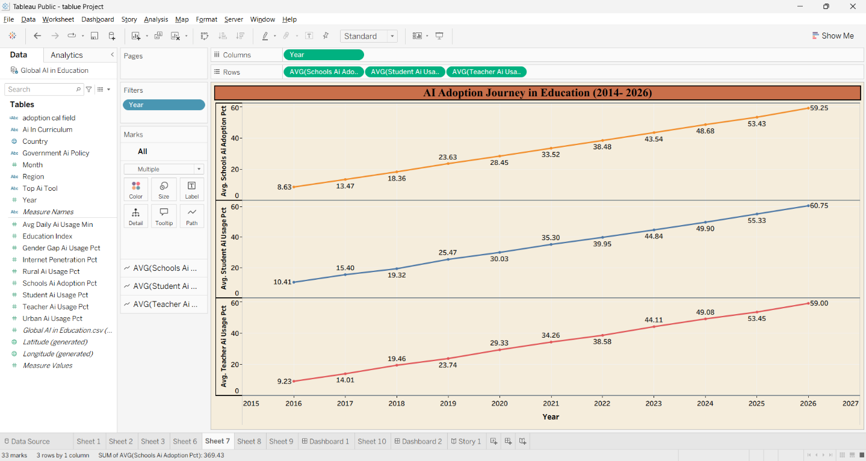

Visualization 6: Comparison of Leading AI Tools
Chart Type: Donut Chart

Purpose
Compares the popularity of leading AI tools used in education. AI Tools Included
- ChatGPT
- Google Gemini
- Microsoft Copilot
- Khanmigo

Insight
- ChatGPT is the most widely used educational AI tool.
- Microsoft Copilot and Google Gemini have comparable usage.
- The distribution indicates healthy competition among AI platforms.

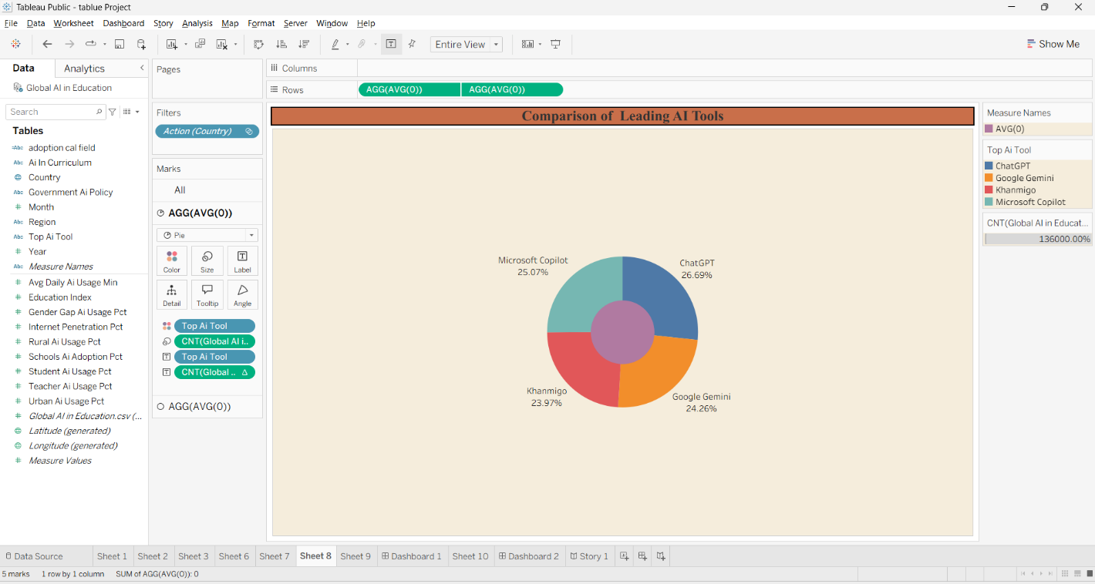

Visualization 7: Growth of Usage Across Rural and Urban Communities
Chart Type: Diverging Bar Chart
Purpose
Compares AI adoption between rural and urban communities over time.

Insight
- Urban AI usage consistently exceeds rural AI usage.
- Both rural and urban adoption increase each year.
- The visualization highlights the digital divide between urban and rural educational institutions.

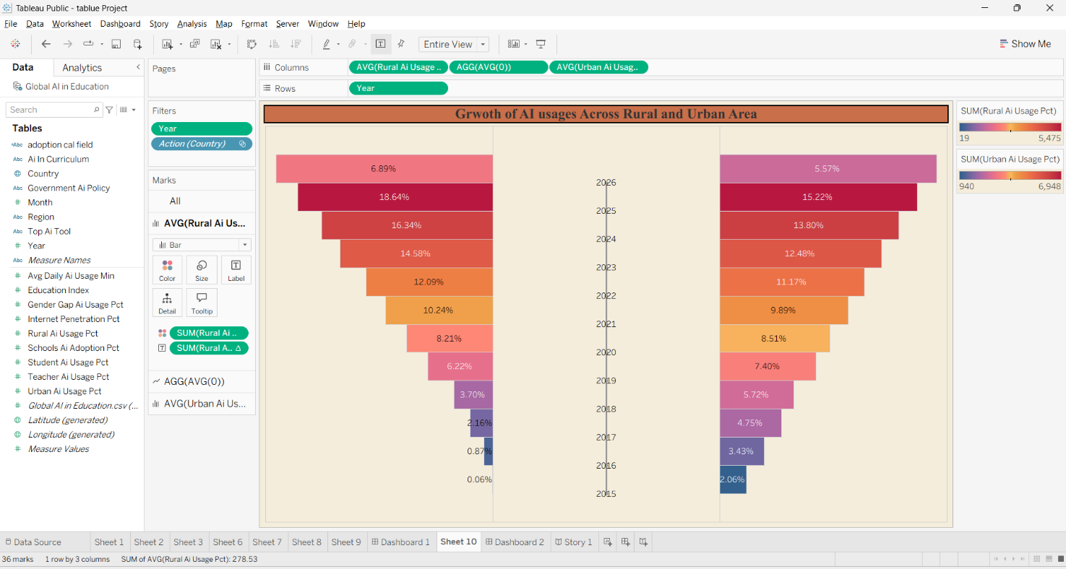

Visualization 8: Comparative View of School AI Adoption Across Regions
Chart Type: Donut Chart
Purpose
Compares school AI adoption across six geographical regions.

Regions Included
- Africa
- Asia
- Europe
- North America
- Oceania
- South America

Insight
- School AI adoption is relatively balanced across all regions.
- Oceania has a slightly higher average adoption percentage.
- The chart enables quick regional comparison.

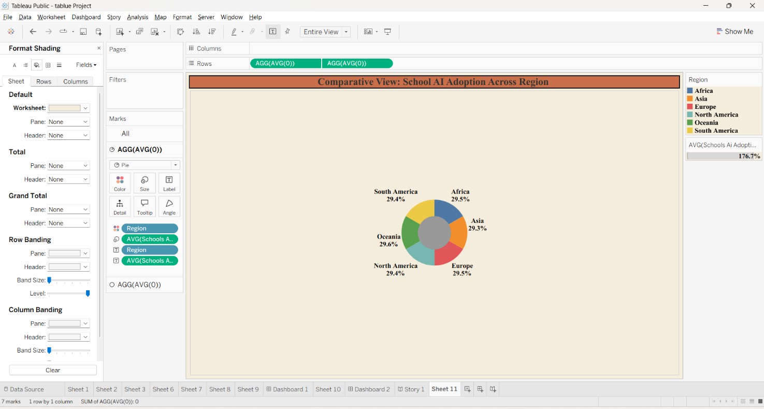

Visualization 9: AI Adoption Level Breakdown Chart Type: Bar Chart Purpose
Classifies records into three adoption categories. Categories
- High Adoption
- Moderate Adoption
- Low Adoption

Insight
- Low Adoption contains the highest number of records (680).
- Moderate Adoption includes 473 records.
- High Adoption contains 207 records.
- The results indicate that many institutions are still in the early stages of AI adoption.

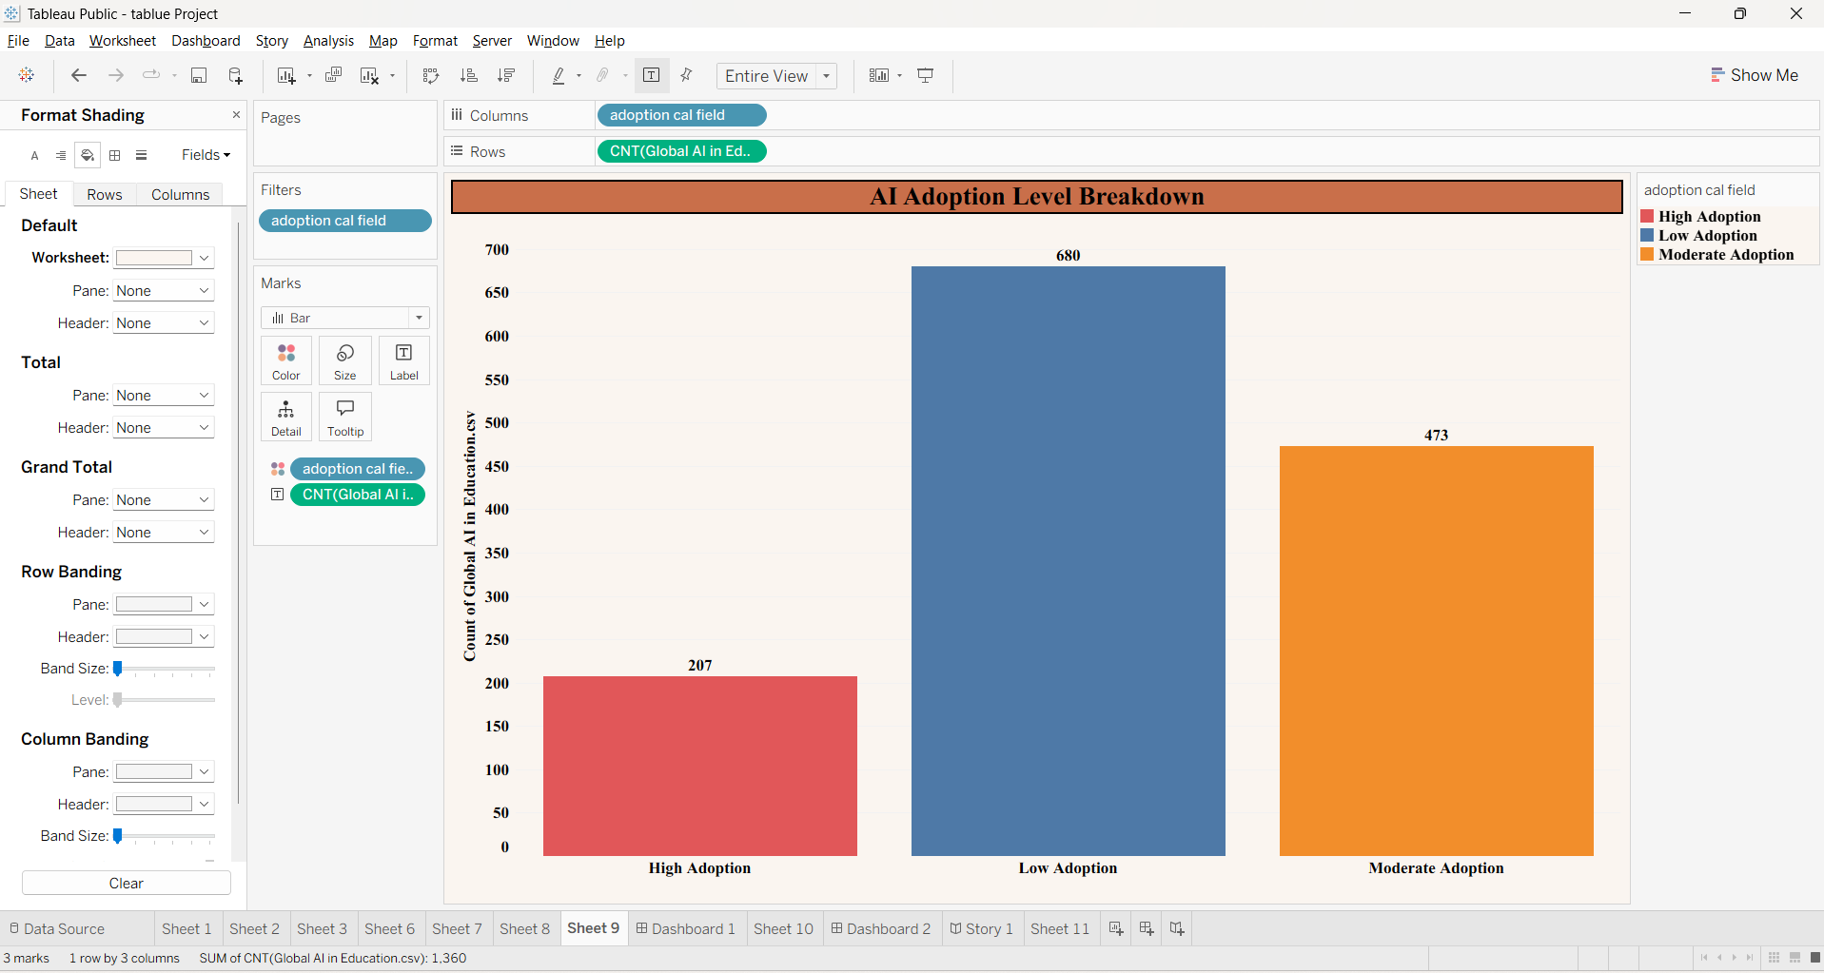

- Dashboard
5.1. Dashboard Design File
Two interactive dashboards were developed in Tableau to provide a comprehensive view of AI adoption in education across different countries and regions.

Dashboard 1: Global AI Adoption in Education Dashboard
Purpose:
This dashboard provides a high-level overview of AI adoption in education using KPIs, maps, trend charts, and comparative visualizations.

Dashboard Components
Component | Description
KPI Cards | Displays Average Daily AI Usage (32.8%), Total Records (1,360), Average Rural AI Usage (21.6%), and Average Urban AI Usage (33.6%).
World Map | Shows the geographical distribution of AI adoption across countries.
Adoption  Breakdown | Categorizes records into High, Moderate, and Low AI adoption levels.
AI Adoption Journey | Displays yearly growth in school, student, and teacher AI adoption from 2015 to 2026.
Regional  Comparison | Compares average school AI adoption across continents.
Interactive Filters | Allows users to filter data by Country, Region, Year, and Adoption Level.

Dashboard Insights
- AI adoption has increased continuously over the years.
- Urban areas show higher AI usage than rural areas.
- Most records fall into the Low Adoption category.
- AI adoption is distributed across all major continents with relatively balanced participation.
- Users can dynamically analyze country-wise and year-wise data using filters.

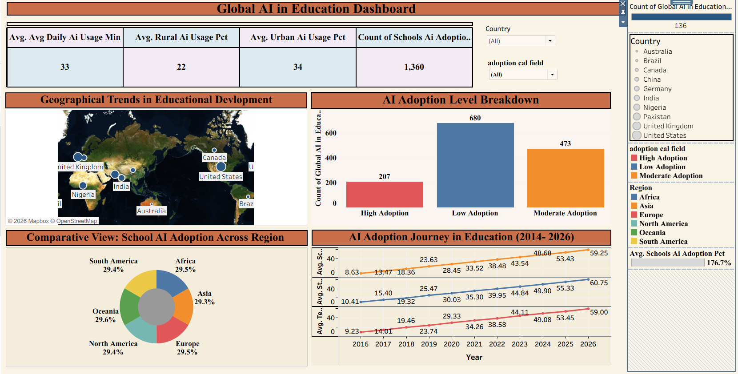

Dashboard 2: Global AI Project – Adoption, Usage, and Growth

Purpose
This dashboard focuses on country-level AI usage, AI tools, student–teacher comparison, and urban–rural adoption trends.

Dashboard Components
Visualization | Purpose
Country-wise Bar Chart | Compares average daily AI usage among countries.
Student vs Teacher Comparison | Compares AI usage percentages between students and teachers.
AI Tool Comparison | Displays market share of leading AI platforms such as ChatGPT, Google Gemini, Microsoft Copilot, and Khanmigo.
Urban vs Rural Analysis | Shows AI adoption differences between urban and rural communities.
KPI Cards | Displays average AI usage indicators.
Filters | Country and Year filters enable interactive analysis.

Dashboard Insights
- Canada recorded the highest average daily AI usage among the selected countries.
- Student AI usage is consistently higher than teacher AI usage.
- ChatGPT is the most widely used AI tool.
- Urban AI adoption is considerably higher than rural adoption.
- AI adoption has shown steady growth over recent years.

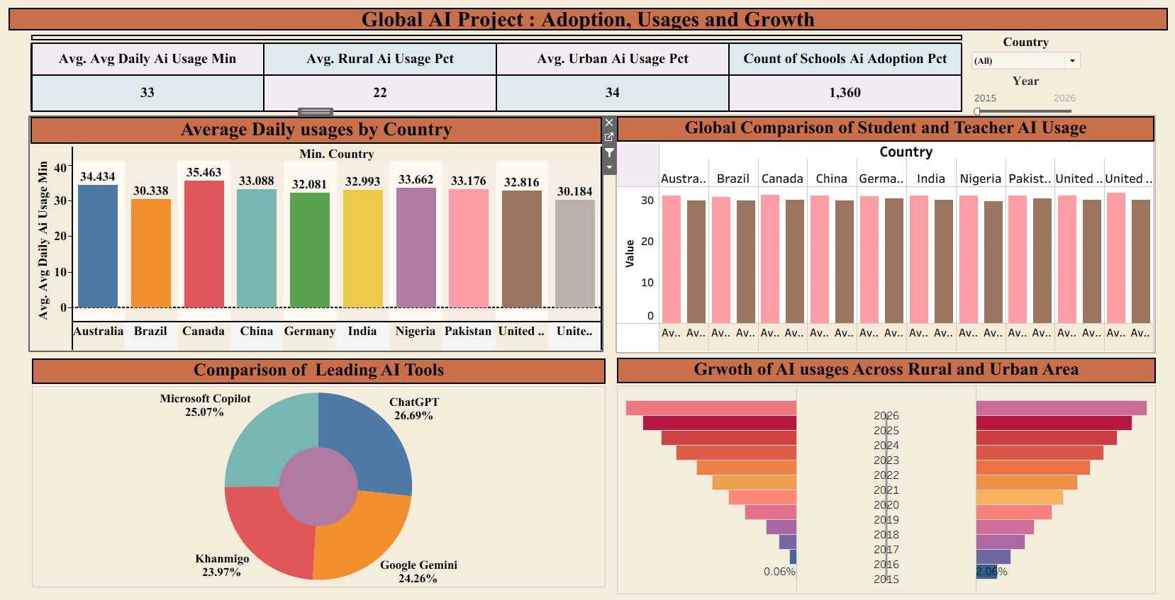

- Report
6.1. Story Design File
A Tableau Story was created to present the analysis in a logical sequence, enabling users to understand AI adoption through multiple perspectives.

Story Name Global AI in Education Challenge

Story Points Story Point 1: Geographic Disparity
- Displays AI adoption across countries using a world map.
- Highlights geographical differences in AI implementation.
- Helps identify countries with greater AI adoption.

Story Point 2: Temporal Trends
- Shows AI adoption growth between 2015 and 2026.
- Student, teacher, and school AI adoption all increase steadily over time.
- Indicates continuous investment in AI-enabled education.

Story Point 3: AI Tool Competition
- Compares leading educational AI tools.
- ChatGPT has the highest usage.
- Microsoft Copilot, Google Gemini, and Khanmigo also have significant adoption.

Story Point 4: Digital Equity
- Compares AI adoption between urban and rural communities.
- Urban AI usage is consistently higher.
- Indicates the existence of a digital divide.

Story Point 5: Stakeholder Engagement
- Compares AI usage between students and teachers.
- Students show slightly higher AI adoption.
- Demonstrates increasing AI acceptance among educational stakeholders.

- Performance Testing
7.1. Utilization of Data filters
The dashboards use multiple interactive filters to improve user experience.

Filters Used

Filter Purpose
Country Analyze individual countries
Region Compare continents
Year Analyze trends over time
Adoption Level Filter High, Moderate, and Low adoption AI Tool Compare leading AI tools

Total Filters Used: 5

7.2. No of Calculation Field

The project uses calculated fields for:
- Average AI Usage
- AI Adoption Level Classification
- Percentage Calculations
- KPI Calculations
- Growth Indicators

Total Calculated Fields: 5

7.3. No of Visualization

Visualization | Count
KPI Cards | 4
World Map | 1
Bar Charts | 2
Line Charts | 1
Donut Charts | 2
Diverging Bar Chart | 1
Student–Teacher Comparison | 1

Total Visualizations: 12

- Conclusion/Observation

The project successfully analyzed global AI adoption in education using Tableau. The dashboards revealed important insights regarding AI implementation across countries, regions, educational institutions, and stakeholders.
The analysis indicates that AI adoption has grown consistently from 2015 to 2026. Urban regions demonstrate higher AI usage than rural areas, highlighting the need to improve digital access in underserved communities. Student AI usage is slightly higher than teacher AI usage, reflecting increasing acceptance of AI-based learning tools. ChatGPT emerged as the most frequently used AI platform among the leading educational AI tools. Interactive dashboards and stories provide an effective way to explore data, compare regions, and support evidence-based decision-making for educators and policymakers.

- Future Scope

The project can be extended in several ways:
  - Include data from more countries and educational institutions.
  - Integrate real-time educational AI datasets.
  - Develop predictive models using Machine Learning.
  - Forecast future AI adoption trends.
  - Add institution-level and student performance analysis.
  - Publish dashboards online using Tableau Public or Tableau Server.
  - Develop a web-based analytics portal for policymakers.

- Appendix

10.1. GitHub & Project Demo Link

Project Demo Link -

GitHub Link – https://github.com/shreyashmhettar/Global-AI-Adoption-in-Education

